**MACHINE LEARNING FOR IMAGE PROCESSING**

**PROPOSAL/ARCHITECTURAL DETAILS**

**DATASET PREPARATION**

* I will be training the model using wet tissue paper images and labeling them using annotating tools. For this case I used VIA tools.

<http://www.robots.ox.ac.uk/~vgg/software/via/via.html>

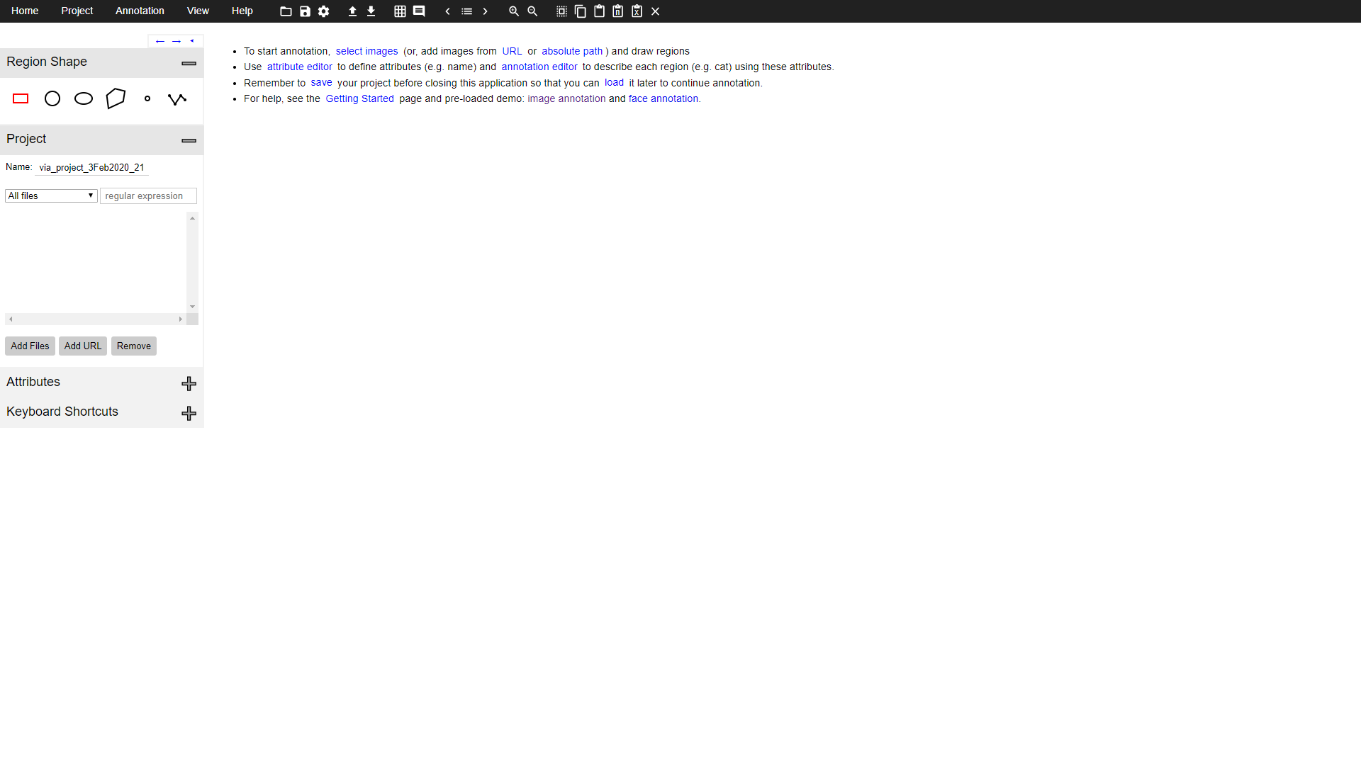

* There is only 1 class “tissue_paper” which is to detect the tissue paper.

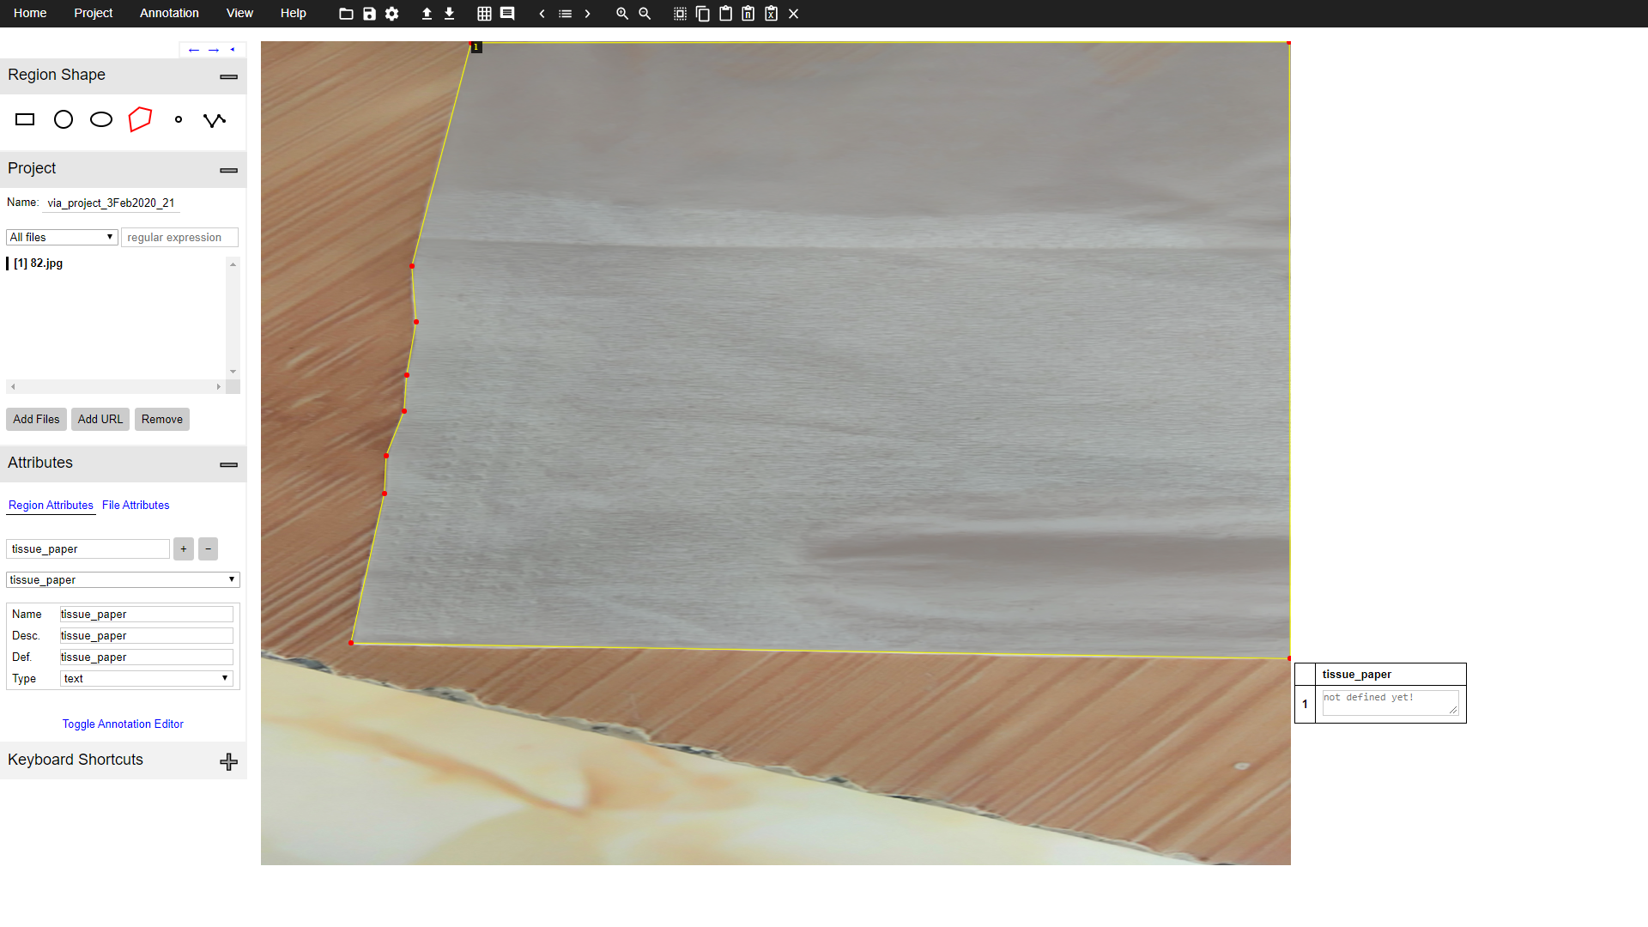

* These images should be in different lightning conditions, different backgrounds and different angles. We need at least ten images per situation. We have around 50 images for annotations to get started.

**PLATFORMS FOR OBJECT DETECION**

* We have a choice to choose between any of the platforms i.e. Tensorflow, Keras and Pytorch. We chose Tensorflow specifically because it has better model performance for object detection and there is a lot of community support for it.



* The tensorflow object detection API is the first one that gets any performance upgrade before the other ML APIs.

**CHOOSING THE ARCHITECTURE**

* There are many architectures used for object detection like Yolo, SSD MobileNet, Faster RCNN V2 inception etc. These architectures outputs a rectangle around the object of interest along with the detected class.

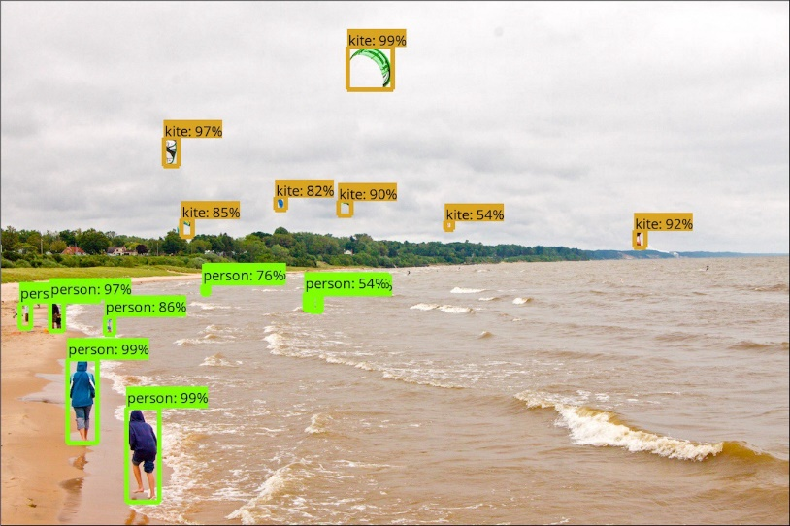

* Our task here is to also get the area upon which water has been spilled.
* Area of interest can only be detected by a very few algorithms among which the Mask-RCNN is the best performing architecture as of now.

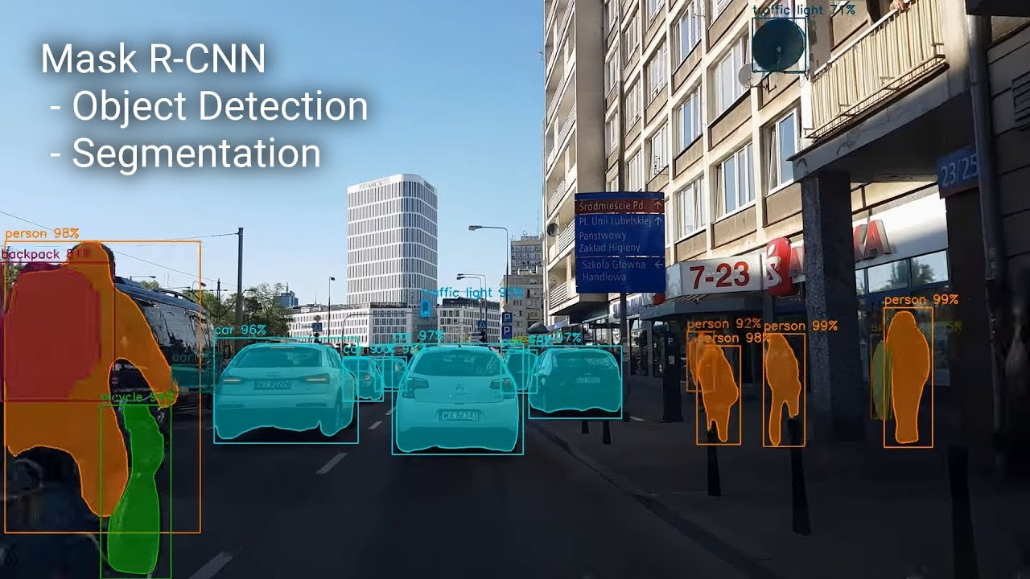

* Mask-RCNN extracts the area of interest pixel by pixel basis, which is known as segmentation. It also does the detection and classification job.

**IMPLEMENTING THE USE CASES**

1. **Identify the tissue paper area:**

Our very first task is to detect the whole tissue paper area.

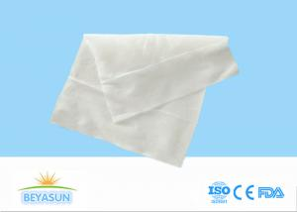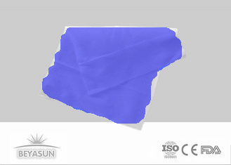

1. **Identify surface area that is Wet and Dry:**

For this I can think of 2 ways:

1. Easy way: given the detected tissue paper area by Mask-RCNN, we then can use OpenCV analysis to count wet and dry pixels with the help of hue, saturation values which will help us to roughly identify the shadowy and transparent areas relative to the dry and bright areas.
2. Hard way: It might be possible that we can also annotate the wet and dry spots by hand and train the model to mask them as well. But this is a tedious task and the results are yet to be seen because the shapes and shades are infinite, and the shadows can be confused for wet spots.

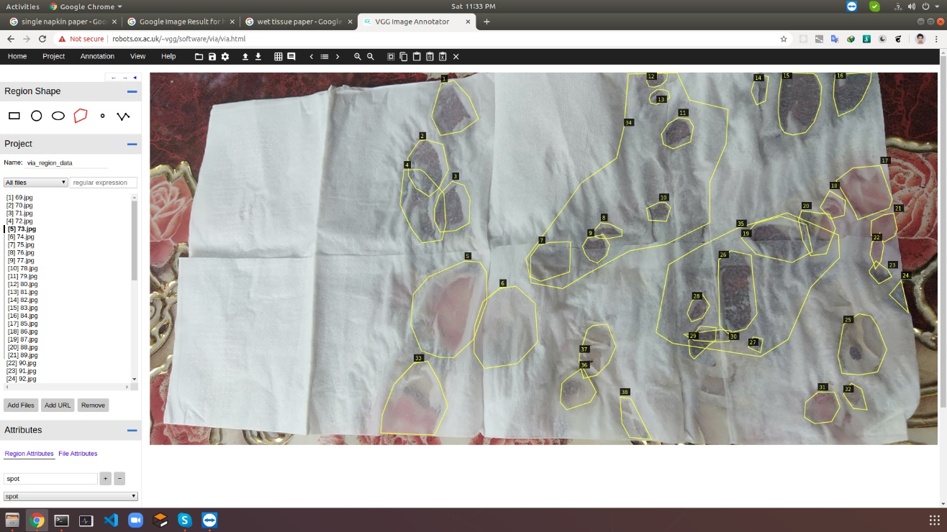

1. **Its size & pattern of water absorption (Mark wet area on image):**

The wet area size and pattern is shown as blue overlay on the tissue paper area.

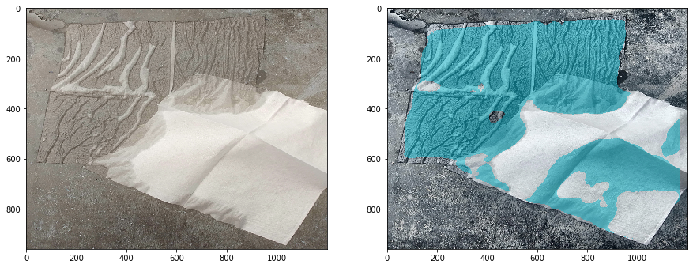

1. **What % is wet to decide its absorbing quality. I don’t need exact % but let’s say in 5% scale:**

For this part I am going to use following formula:

**total = Tissue Paper Area,**

**total = wet_pixels + dry_pixels**

**wet = wet_pixel*100/total**

**dry = dry_pixel*100/total**

**Example output:**

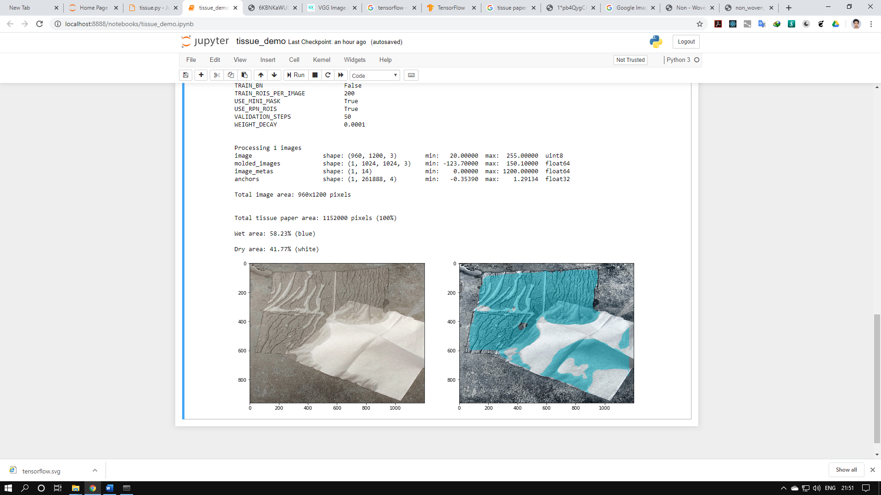

**ADDRESSING YOUR ISSUES**

### 6. Parameters to the model thru REST API

We need to test by sending images to Model REST API

Model must return results in sub seconds.”

**SOLUTION:**

I will be using Faster RCNN V2 inception because it is our best choice for high speed with a good accuracy. It will give you the results in seconds which is your requirement.

### 7. Accuracy of model and re-calibration

Often the model will fail for certain images where pattern is not seen earlier.

How do we take care of it?

How can we train model for these new images and if we had to carry any manual corrections how to feed them back into model?”

**SOLUTION:**

We can train the model with new images every day and deploy it

### 8. Test Images

Look at these images and remark them which model can process successfully?”

**SOLUTION:**